STAFF BULLETIN


Week Commencing 3 October 2011

HEAD’S FOCUS FOR THE WEEK: To ensure students that are required to help in your departments on Open Evening receive the required permission letters as soon as possible and please continue to update displays ready for Open Week

Assemblies: Mrs J Pepper
VI Form Assembly: Miss K McEwan and Mr R Craig

SLT to meet daily at 8.30 am

OFF ROLL: None

ON ROLL: Joshua Tregunno (Year 9)

Collective Act of Worship: LIGHT

All classroom bookings to be made through Cover Manager
All other room bookings to be made through Mrs H Frost

Please note later in bulletin Guidance to the people present in the Examination Room

Mon 3/10/2011 Year 13 AS Resit Mocks: Ensure that Sixth Form Students who are sitting resit in January have appropriate exam practice this week

Mr D Windeatt on course all day

Heads of Year to arrange Student Council Year Group meetings this week

Laura Howell - PGCE from Anglia Ruskin University to undertake her A Placement in Maths department from 3 October to 1 December, Monday to Thursday

Pd 1 “Student Finance Tour” to give talk on student finance to Year 12&13 - B&E Conference Room

9.15am Mr N Sydenham and Mr Chris Furniss to meet re ICT Strategy

Pd 2 Miss E King to observe Mrs C Boulton – NQT Obs

Pd 2 Mr M Harper to observe Miss S Kemp – NQT Obs

Pd 3 Mrs N Watts to observe Miss A Thyer – GTP Obs

1.10pm Year 8 Student Council Year Group meeting – B&E Conference Room with Mr C Carrott

1.10-5.40pm The following Fish Husbandry students to visit Hanningfield Reservoir accompanied by Mr A De Wet: John Grimes, Bradley Knight,
Tom Mimms, Shaun Scarsbrook, Ben Sparks, Jak Stacey, Jack Rable,
Harry Thomas, Lewis Nash – student’s to be collected from the Reservoir by parents/carers

1.10pm Nigel Spratt – GTP Assessor to meet with Mr S Ansell and Ms T Brabant

Pd 5 Nigel Spratt to meet with Mr S Ansell

Pd 5 Mrs N Watts to observe Miss H Boyce – NQT Obs

Pd 5 Mrs J Pepper to meet with Miss E King

3.00pm Pension presentation for teaching staff – B&E Conference Room

3.00-4.00pm Year 8-11 Writing Group – Mrs R Hodgson – BE4

4.00pm Mr R Hodges to meet with Chair and Vice Chair

5.00-7.00pm Family Learning Introduction to Internet Safety Course – PC3&4 with Lesley Bentley

6.00pm Governors Premises Committee Meeting

Tue 4/10/2011 Final date for November Access arrangements and November exam entries

Mr R Hodges to attend Ofsted Framework Course all day

Miss A Thyer, Mr S Coombs and Mr D Emms on course all day

8.45-10.55am Year 10 English Language Controlled Assessments – West Hall and Sports Hall

Pd 1-4 The following students to attend a Tag Rugby event at Billericay School: Jason Catley and Bradley Holder accompanied by Miss H Stibbs

Pd 4 Mr M Harper to observe Mr T Moss – NQT Obs

2.45pm Miss K McEwan, Mr A Liddell, Mrs L Harte and Miss A Mills to meet re Sixth Form review of results and target setting – B&E Boardroom

2.45pm BTEC Fish Husbandry – DT2

2.45-3.45pm GCSE Coursework session – Mrs N Watts – PC5

2.45-3.45pm Aladdin Rehearsals – Mr D Carlton and Miss H Boyce –
Drama 1 & 2

Wed 5/10/2011 Mr R Craig on course all day

Mr S Ansell on course all day

8.00-11.00am Mr M Harper to attend STTP Directors meeting

8.30am Staff briefing – B&E Conference Room

1.10 Photographs for family groups, individuals and staff who missed the photos on 21 September – West Hall

1.10-1.45pm Chill-Out lunch time club – B&E Conference Room

2.45pm Department meetings

Thu 6/10/2011 Mrs N Watts on course all day

8.00am-2.00pm Mr R Hodges to attend BAP/ASHE Meeting

1.10-4.00pm Mr M Harper to attend APG Meeting

2.45-3.45pm Aladdin Rehearsals – Mr D Carlton, Miss H Boyce and Miss A Thyer – Drama 1 & 2

2.45-3.45pm BTEC Health and Social Care – Mrs G Craig

3.00-4.00pm Year 12&13 Reading Group – Mrs R Hodgson - Library

3.15pm SLT meeting

Fri 7/10/2011 Year 7 transition reports to SL/HOY

Jeans for Genes non-uniform day – students can attend school in non-uniform, which includes denim for £1 to go to the charity – collected during am registration by Sixth Form

8.00am Mr R Hodges to attend Wickford Headteacher’s Meeting at Hilltop Primary School

Pd 2 - Year 11 Hairdressing Exam (Unit 216) in PC1

3.00-4.00pm Accelerated Reading Information Session with Mrs S Perkins - LRC

7.00-9.00pm Year 7 & 8 Welcome Disco – West Hall

Registration – Year 7-11 students to complete weekly achievement sheets

Gold and White 100% punctuality stickers to be issued by tutors at Friday registration (any staff who need more please see General Office)

Form Tutor Monitoring Sheets (Upper School to Mr D Windeatt and Lower School to Mr P Mower) by 3.00pm

HOY Weekly HW diary monitoring sheets due to HOUS/HOLS by 3.00pm

Room Bookings

 | B&E Conf Room | B&E Board Room | West Hall | West Dining Area | Interview Room
Monday |  | Pd 1 A2 Film Studies
Tuesday |  | Pd 1 AS Film Studies |  |  | Pd 2 Sarah Pattinson (YOT)
Wednesday | Chill-Out club – lunch time
Thursday
Friday

HOLIDAY LIST
Ben Paris | 11-07M | 26-Sep-11 | 10-Oct-11
Yasmin Ibrahim | 9-09U | 27-Sep-11 | 05-Oct-11
Ishak Bayraktar | 8-10P | 28-Sep-11 | 05-Oct-11
Romy Oliver | 11-07E | 30-Sep-11 | 03-Oct-11
Oat Saengsangket | 8-10H | 30-Sep-11 | 03-Oct-11
Lauren Brooks | 8-10H | 03-Oct-11 | 14-Oct-11
James Lucas | 11-07A | 06-Oct-11 | 13-Oct-11
Max Lucas | 8-10A | 06-Oct-11 | 13-Oct-11
Jasmine Thorne | 8-10H | 06-Oct-11 | 14-Oct-11

ATTENDANCE PUNCTUALITY

Week commencing 19 Sept 2011 Week commencing 19 Sept 2011
Yr 7 11A 100% Yr 7 11E 100%
Yr 8 10M 99.0% Yr 7 11H 100%
Yr 9 09H 97.2% Yr 7 11U 100%
Yr 10 08H 98.6% Yr 8 10E
Yr 11 07M 98.7% Yr 11 07C

STUDENTS ON REPORT
Year 7 | None | Year 10 | Ashleigh Ford (08P)  Charmian Allnut (08U)
Year 8 | Jordan Fox | Year 11 | Calum Fitzpatrick - effort/progress  Callum Gazzard - effort/progress/homework  Zach crutch -effort/progress/homework  Sophie Webb (ICT rrogress report)
Year 9 | Tyler Moore is - Punctuality and attendance

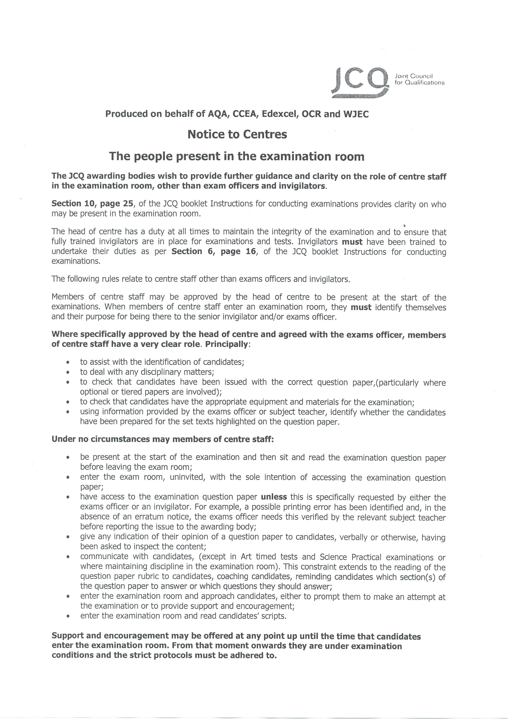

COLLECTIVE ACT OF WORSHIP
Week Beginning
3 October 2011

LIGHT

“Siddhartha meditated under the Bodhi tree until he saw the light, saw the world as it really was and reached Enlightenment”

(The Story of the Buddha)

What could seeing the world as it really was be thought of as seeing the light?

“We kindle these lights on account of the miracles, the deliverance and the wonders which you performed for our ancestors”

(Jewish Prayer Book)

Why would lights remind Jewish people of previous miracles and wonders?

What is light a symbol of to many people?

“You are the light of the world. A city on a hill cannot be hidden. Neither do people light a lamp and put it under a bowl. Instead they put it on its stand, and it gives light to everyone in the house. In the same way let your light shine before men, that they may see your good deeds and praise your Father in heaven”

(Sermon on the Mount – Matthew Chapter 5 Verses 14-16)

Try and put this quote into your own words.

Why are good deeds likened to light?

DETENTIONS RECORD
NAME |  | SEX | TG | REASON | STAFF | DATE
YEAR 7
MARNEY | Neve | F | 11B | No maths homework | Cti | 28/09/2011
LAWRENCE | Megan | F | 11E | No homework | DJo | 26/09/2011
CLARK | Harvey | M | 11E | No homework | DJo | 26/09/2011
STIFFELL | Tommy | M | 11E | No homework | DJo | 26/09/2011
PRITCHARD | George | M | 11E | No homework | DJo | 26/09/2011
YEAR 8
BUCHANAH-JONES | Tyla | F | 10M | Maths homework not given in | Dca | 26/09/2011
YEAR 9
VINCENT | Luke | M | 09A | No homework | ATh | 26/09/2011
SIPPITT | Jaque | M | 09A | No homework | ATh | 26/09/2011
OLUROTIMI | Daniel | M | 09A | 3 x lates | ESm | 28/09/2011
BAJEH | Naz | F | 09B | 3 x lates | ESm | 28/09/2011
BAJEH | Naz | F | 09B | Failing to complete homework scoring 2/19 | MCu | 26/09/2011
BAJEH | Naz | F | 09B | Missed detention, 2 x lates | MGr | 22/09/2011
COOK | Bobbie | F | 09C | No homework | ATh | 26/09/2011
MCGONNELL | Danny | M | 09C | 5 x lates | ESm | 28/09/2011
LATCHFORD | Jack | M | 09C | Failing to hand in homework | MCu | 26/09/2011
COOK | Bobbie | F | 09C | Failing to hand in homework | MCu | 26/09/2011
PIGG | Millie | F | 09C | Failing to hand in homework | MCu | 26/09/2011
VARNALS | Alicia | F | 09C | Failing to hand in homework | MCu | 26/09/2011
KING | Tom | M | 09C | Failing to complete homework scoring 1/19 | MCu | 26/09/2011
COOK | Bobbie | F | 09C | Not complete detention homework | Asa | 27/09/2011
COOK | Bobbie | F | 09C | Chewing gum and foul language | Adw | 29/09/2011
COOK | Bobbie | F | 09C | Said to Remi E "I will bite your testicles off" | MGr | 26/09/2011
CONNOLLY | Curtis | M | 09E | No homework | ATh | 26/09/2011
CANNON | Ryan | M | 09E | No homework | ATh | 26/09/2011
BAYOKO | Prisca | F | 09E | 3 x lates | ESm | 28/09/2011
CRITTENDEN | Johnny | M | 09E | 3 x lates | ESm | 28/09/2011
BAYOKO | Prisca | F | 09E | Fighting in class | MGr | 29 & 30/09/2011
GANDY | James | M | 09E | 2 x lates w/b 19 September 2011 | Eki | 28/09/2011
CANNON | Ryan | M | 09E | 2 x lates w/b 19 September 2011 | EKi | 28/09/2011
TAYLOR | Shanice | F | 09H | No homework | ATh | 26/09/2011
MARRIAGE | Colby | M | 09H | No homework | ATh | 26/09/2011
PHILLIPS | Jordan | M | 09H | No homework | ATh | 26/09/2011
BUCKLEY | Jack | M | 09H | Two homeworks missing | SJo | 30/09/2011
PARRY | Josh | M | 09H | Not done two homeworks set in English this term | SJo | 30/09/2011
DEMETRIOU | Nicole | F | 09H | Failing to hand in homework | MCu | 26/09/2011
SIMMONS | Tom | M | 09M | Two homeworks missing | Sjo | 26/09/2011
MOORE | Tyler | M | 09M | Failure to attend detention | SJo | 26/09/2011
HIGGINS | Tom | M | 09M | 5 x lates | ESm | 28/09/2011
HIGGINS | Tom | M | 09M | Not completing homework, not turning up to detentions | Jsi | 30/09/2011
HAMMOND | Ben | M | 09P | No homework | Aco | 27/09/2011
BARTHOLOMEW | Reece | M | 09P | Failing to hand in homework | MCu | 26/09/2011
VISCARDINI | Cj | M | 09U | No homework | ATh | 26/09/2011
MARSH | Craig | M | 09U | Bad behaviour in lesson | CLm | 30/09/2011
HANNABUSS | Billy | M | 09U | Rescheduled from 21/9 as unwell. | ACo | 26/09/2011
VISCARDINI | CJ | M | 09U | 3 x lates | ESm | 28/09/2011
VISCARDINI | CJ | M | 09U | Failing to hand in homework | MCu | 26/09/2011
MARSH | Craig | M | 09U | Failure to attend previous detention | ESm | 29/09/2011
YEAR 10
SUMNER | Lauren | F | 08A | Not completing homework | AMi | 27/09/2011
TREMAYNE | James | M | 08A | No maths homework | CTi | 28/09/2011
SMITH | Jamie | M | 08B | Not completing homework | IBu | 26/09/2011
SMITH | Jamie | M | 08B | Off task, disruptive | SFo | 30/09/2011
SMITH | Jamie | M | 08B | Refusal to attend detention in history for 1 hour | GCr | 28/09/2011
HULL | Ben | M | 08C | Disruption, talking over teacher and being rude | Jsi | 28/09/2011
BUTLER | Ryan | M | 08E | No homework | MGi | 28/09/2011
HARVEY | Cameron | M | 08E | No homework | MGi | 28/09/2011
MORRIS | Michaela | F | 08E | No homework | Ami | 27/09/2011
RABLE | Jack | M | 08E | Off task | SFo | 30/09/2011
BEADLE | Nicholas | M | 08H | 4 x lates | GCr | 29/09/2011
BENNETT | Jake | M | 08H | Inappropriate language | Djo | 26/09/2011
CHARLICK | Tor | F | 08H | No homework | AMi | 27/09/2011
MARSH | Drew | M | 08H | Off task, internet games | SFo | 30/09/2011
MURPHY | Billy | M | 08H | Off task, internet games | SFo | 30/09/2011
CHALMERS | Jaime | F | 08M | Writing graffiti on maths textbook | Cti | 27/09/2011
TOVEY | Ross | M | 08M | Off task, internet games, walking around, rude, swearing,disruptive | SFo | 30/09/2011
BURNS | Charlie | M | 08P | 2 x late last week | DJo | 26/09/2011
GAULD | Alex | M | 08P | 2 x late failed to turn up to detention | DJo | 26/09/2011
GAULD | Alex | M | 08P | 3 x lates | GCr | 29/09/2011
HALES | Robyn | F | 08P | 2 x late last week | Djo | 26/09/2011
MORRIS | Dean | M | 08P | No homework | AMi | 27/09/2011
WALDRON | Connor | M | 08P | Disruptive, not following instructions, incomplete homework | Tha | 26/09/2011
BARTLETT | Mollie | F | 08U | Maths homework not given in | Dca | 26/09/2011
FOX | Jordan | M | 08U | Missed detention | ADw | 29/09/2011
FOX | Jordan | M | 08U | No homework | ADw | 21/09/2011
NOLAN | Tyler | M | 08U | Failed to hand in two homeworks | Mco | 26/09/2011
WARD | Codey | M | 08U | Off task, disruptive | SFo | 30/09/2011
WARD | Codey | M | 08U | Failure to attend detention for lack of work | Ibu | 26/09/2011
YEAR 11
BAYOKO | Christian | M | 07A | 3 x lates | MSp | 29/09/2011
KELLY | Laura | F | 07A | 3 x lates | MSp | 29/09/2011
LINIHAN | Poppy | F | 07A | 3 x lates | MSp | 29/09/2011
BROOMFIELD | Jake | M | 07E | No homework | SRe | 27/09/2011
TAYLOR | James | M | 07E | Truanting | Sci | 28/09/2011
TAYLOR | James | M | 07E | 4 x lates | MSp | 29/09/2011
LAWRENCE | Liam | M | 07E | 4 x lates | MSp | 29/09/2011
BROOMFIELD | Jake | M | 07E | To catch up on geography work | MSp | 26/09/2011
BAX | Callum | M | 07H | Truanting | SCi | 28/09/2011
LITTLE | Mat | M | 07H | Truanting | SCi | 28/09/2011
OLIVER | Jack | M | 07H | 3 x lates | MSp | 29/09/2011
HUNT | Grace | F | 07H | 4 x lates | MSp | 29/09/2011
ELEY | Mitchell | M | 07M | Failed to turn up on 20/9/11 for failing to complete Unit 2 | Djo | 29/09/2011
LIPLEY-HINTON | Renee | F | 07M | 3 x lates | MSp | 29/09/2011
FREGENE | Ebison | M | 07P | No homework | SRe | 27/09/2011
SIMPSON | Bradley | M | 07P | Truanting | SCi | 28/09/2011
REILEY | Michael | M | 07P | Spray aftershave in classroom, rude and threatening behaviour | DJo | 26/09/2011
BARRATT | Michael | M | 07P | Missed 2 x lunchtime meetings | Cti | 27/09/2011
COOK | Jessica | F | 07U | No homework | SRe | 27/09/2011
CARTER | Josh | M | 07U | No homework | SRe | 27/09/2011
WEBB | Sophie | F | 07U | Incomplete coursework Unit 2 | DJo | 26/09/2011
CLEGG | Jack | M | 07U | Truanting | SCi | 28/09/2011

